Database Report #3

8/8/19

## Completed this week

- Added Many more functions for the app to be able to use the database, selecting data, inserting, and updating.

- Added the routes for each new function for easy local testing of each function.

- Added views to the database so the app isn’t hitting the actual tables for every query

- Communicated with the front-end team to make sure all the necessary functionality is included in the database

- Communicated with the back-end team to find out what kind of commenting etc would be useful to get the functions set up

- Created a detailed documentation file explaining each function

- Created a file with function samples for the specific functionality requested by the front-end

** See below for this week’s additions to our functions and database

## Coming Up...

- Testing of each function locally to make sure they all work as expected

- Further communication with the back-end team to make sure they are able to use our functions

- Adding more sample-data

- Adding further documentation to our python files.

Weekly Report 4, Thursday 8/8/19

This week we accomplished:

* Added Many more functions for the app to be able to use the database, selecting data, inserting, and updating.
* Added the routes for each new function for easy local testing of each function.
* Added views to the database so the app isn’t hitting the actual tables for every query
* Communicated with the front-end team to make sure all the necessary functionality is included in the database
* Communicated with the back-end team to find out what kind of commenting etc would be useful to get the functions set up
* Created a detailed documentation file explaining each function
* Created a file with function samples for the specific functionality requested by the front-end

Next week:

* Testing of each function locally to make sure they all work as expected
* Further communication with the back-end team to make sure they are able to use our functions
* Adding more sample-data
* Adding further documentation to our python files.

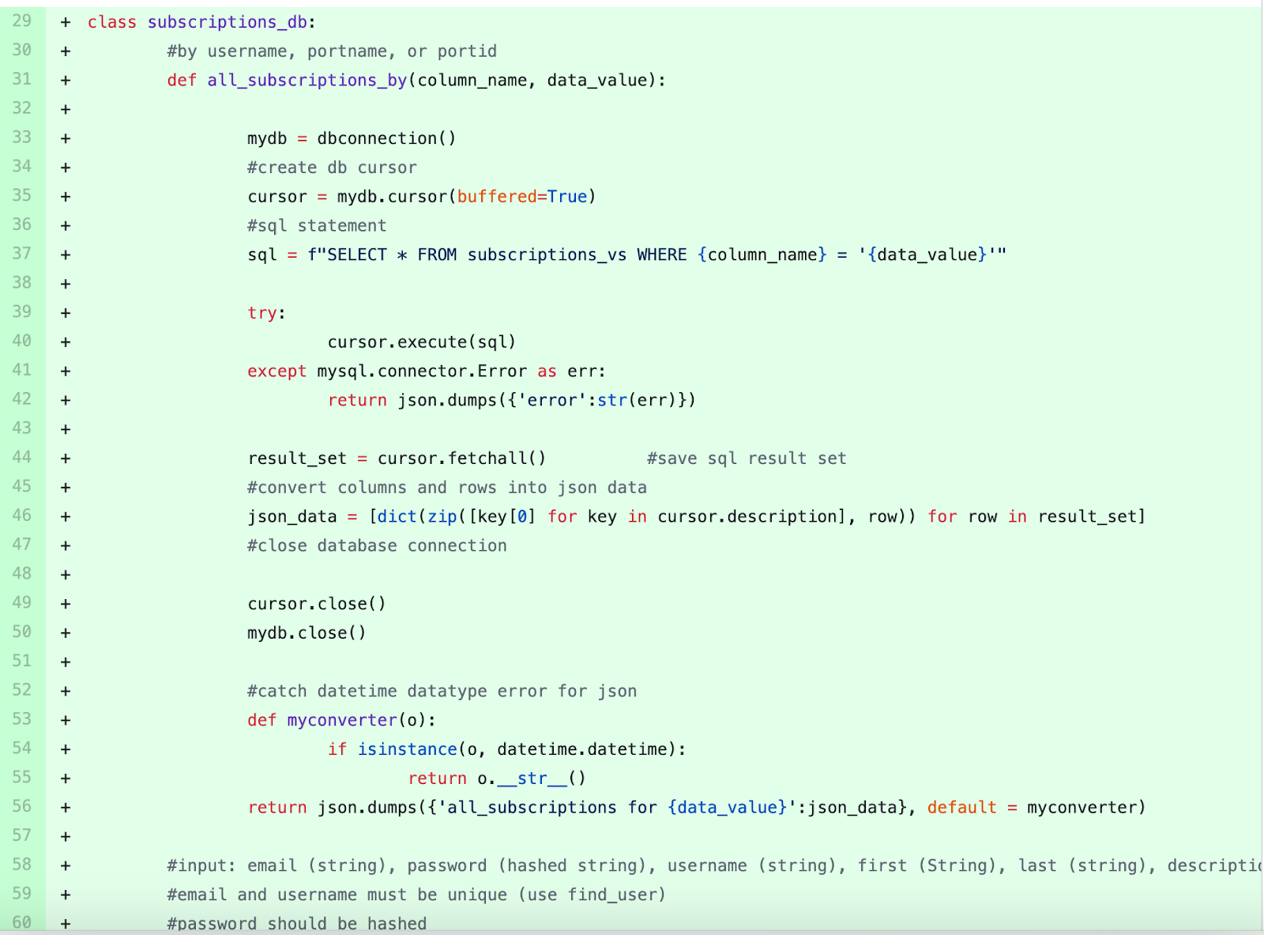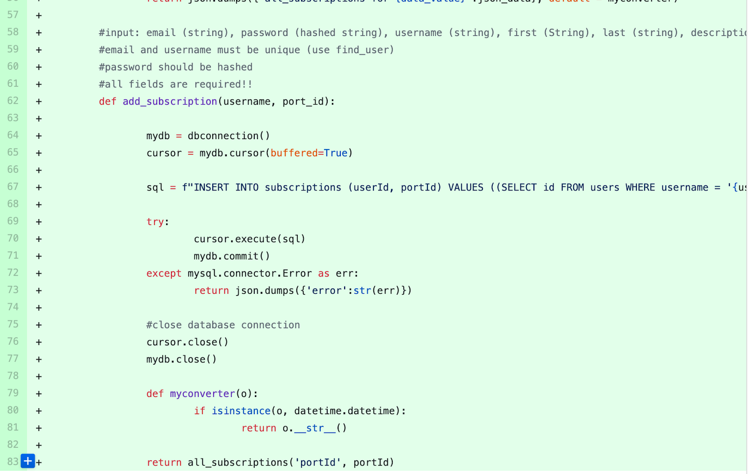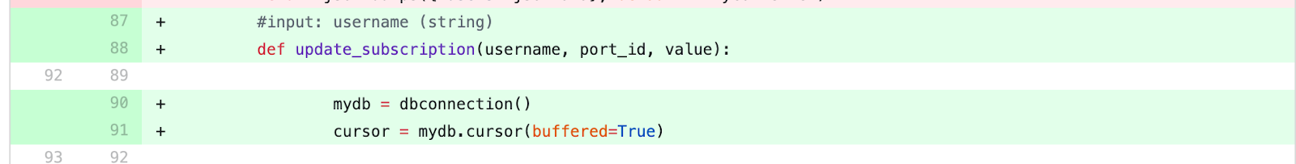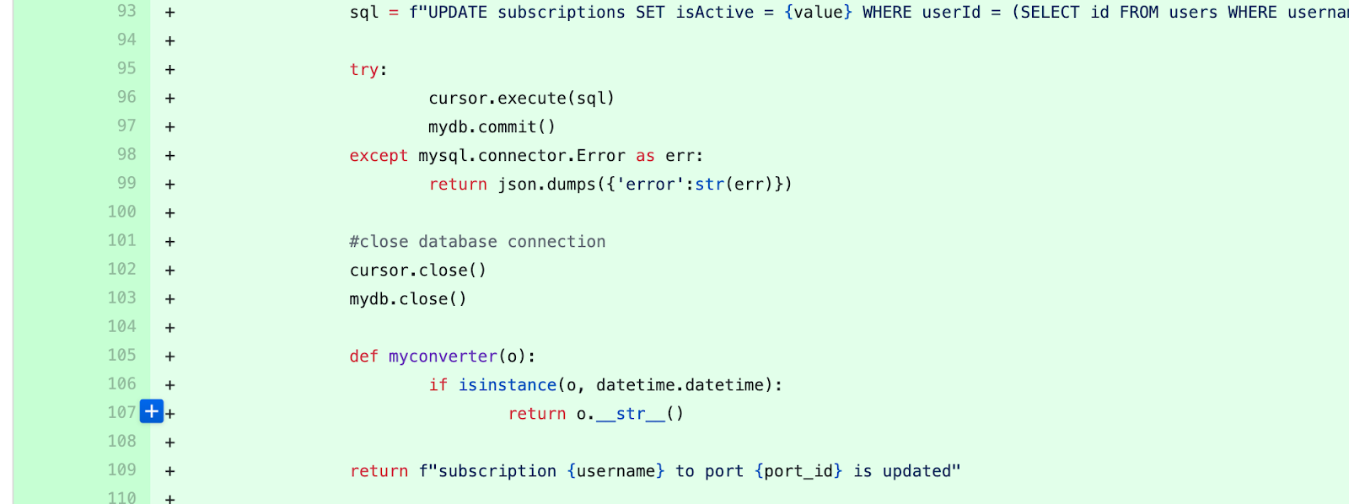https://lh4.googleusercontent.com/GCye-h8d41BOpYgq7-BxlvaRNCOu92PAYbxR2mOaOuroE7oL2T_yLP1Un8RVUonjqA5leQ7_WNmcybtGclHW2wkKppwBDx3aamZWl6Mlvc1YoAwvbEf-0mkMP_7VAZAYiQkotwAFUKcFwvVSOg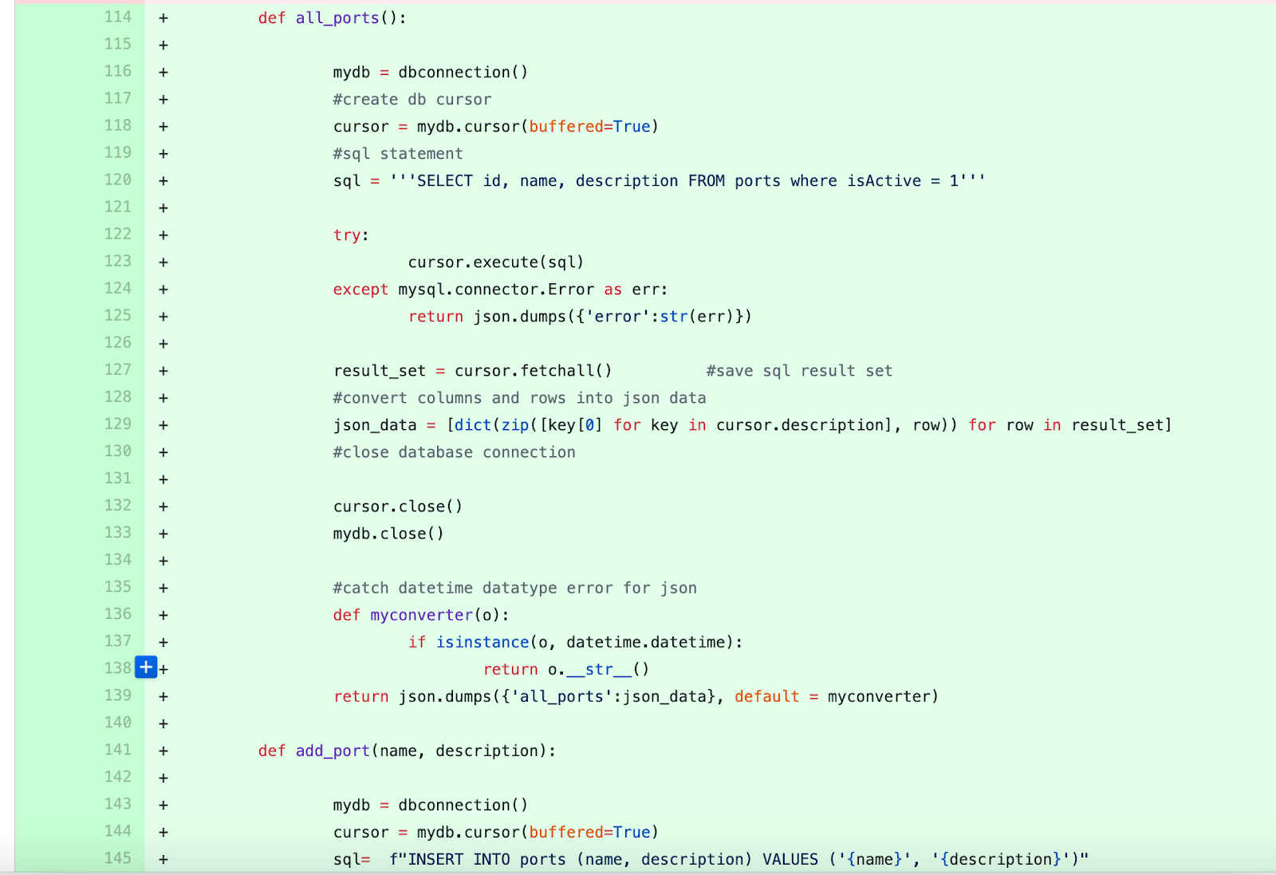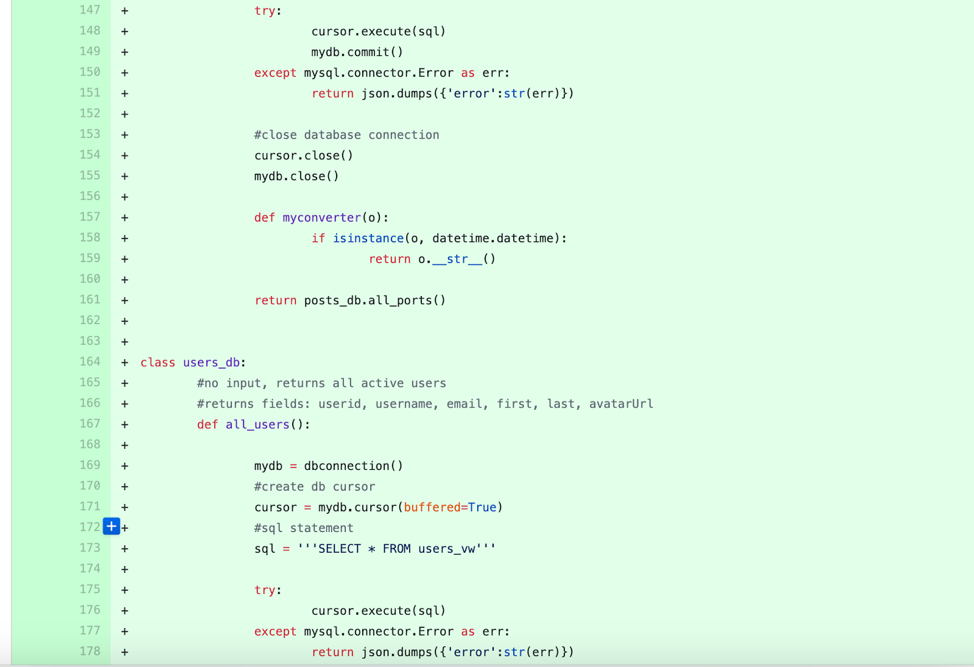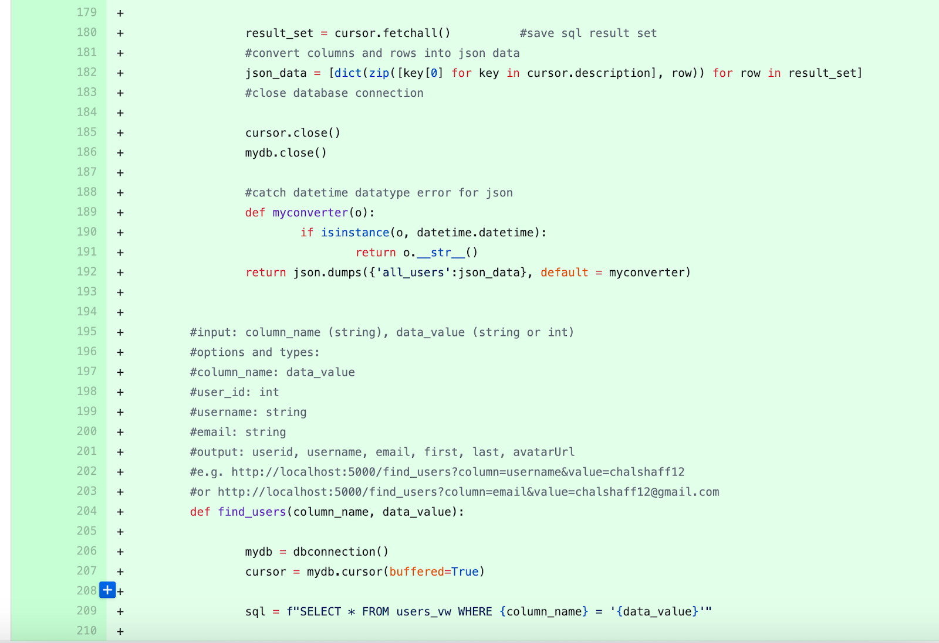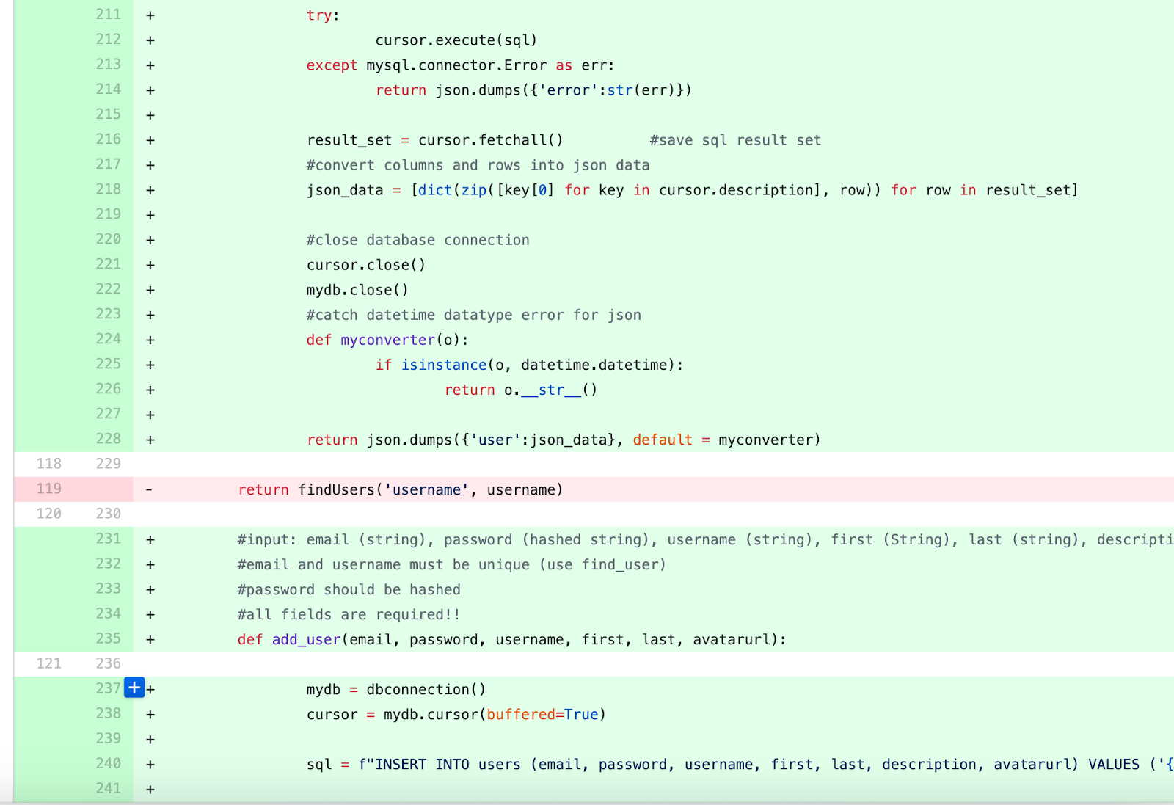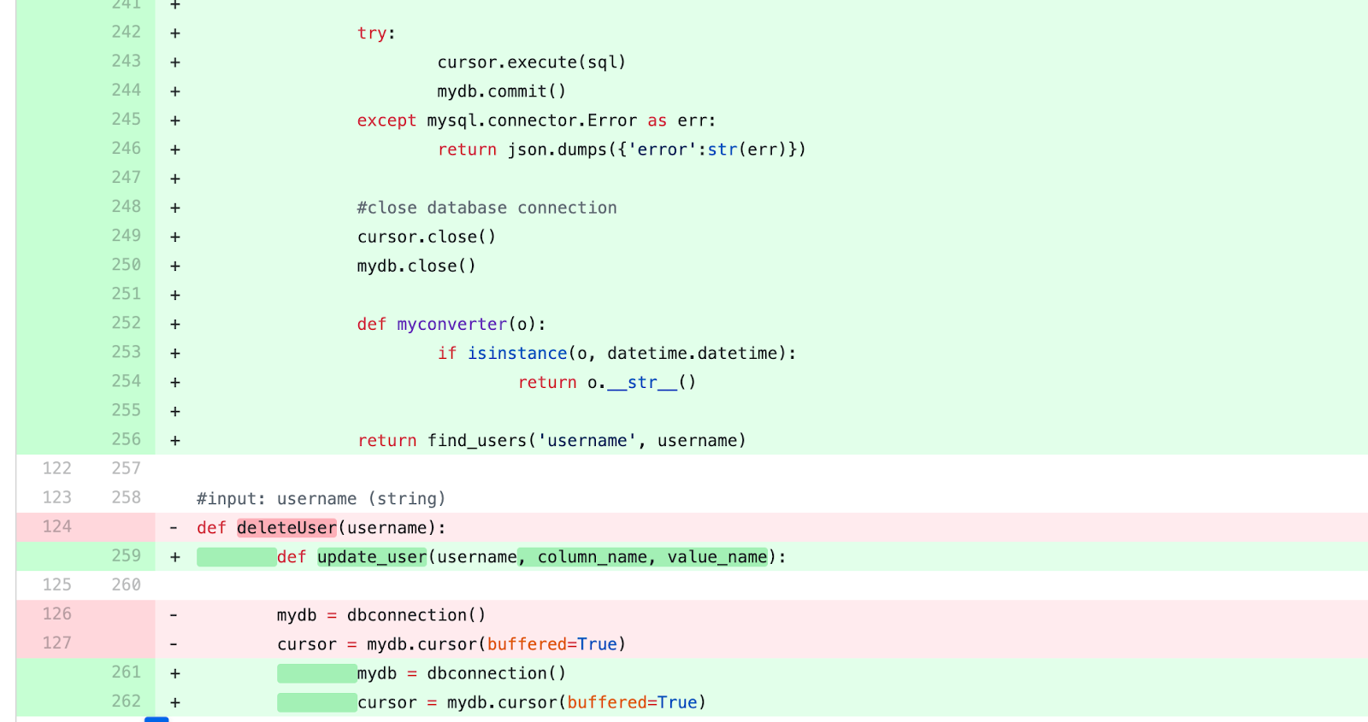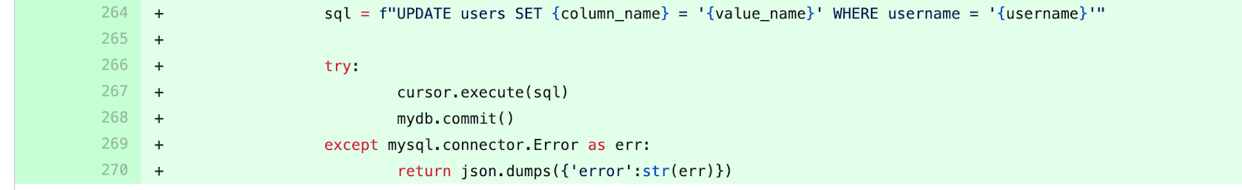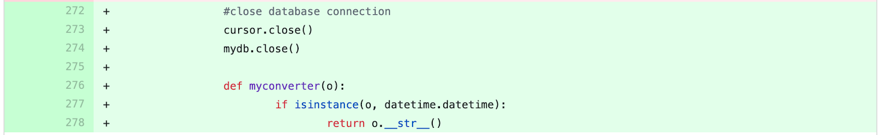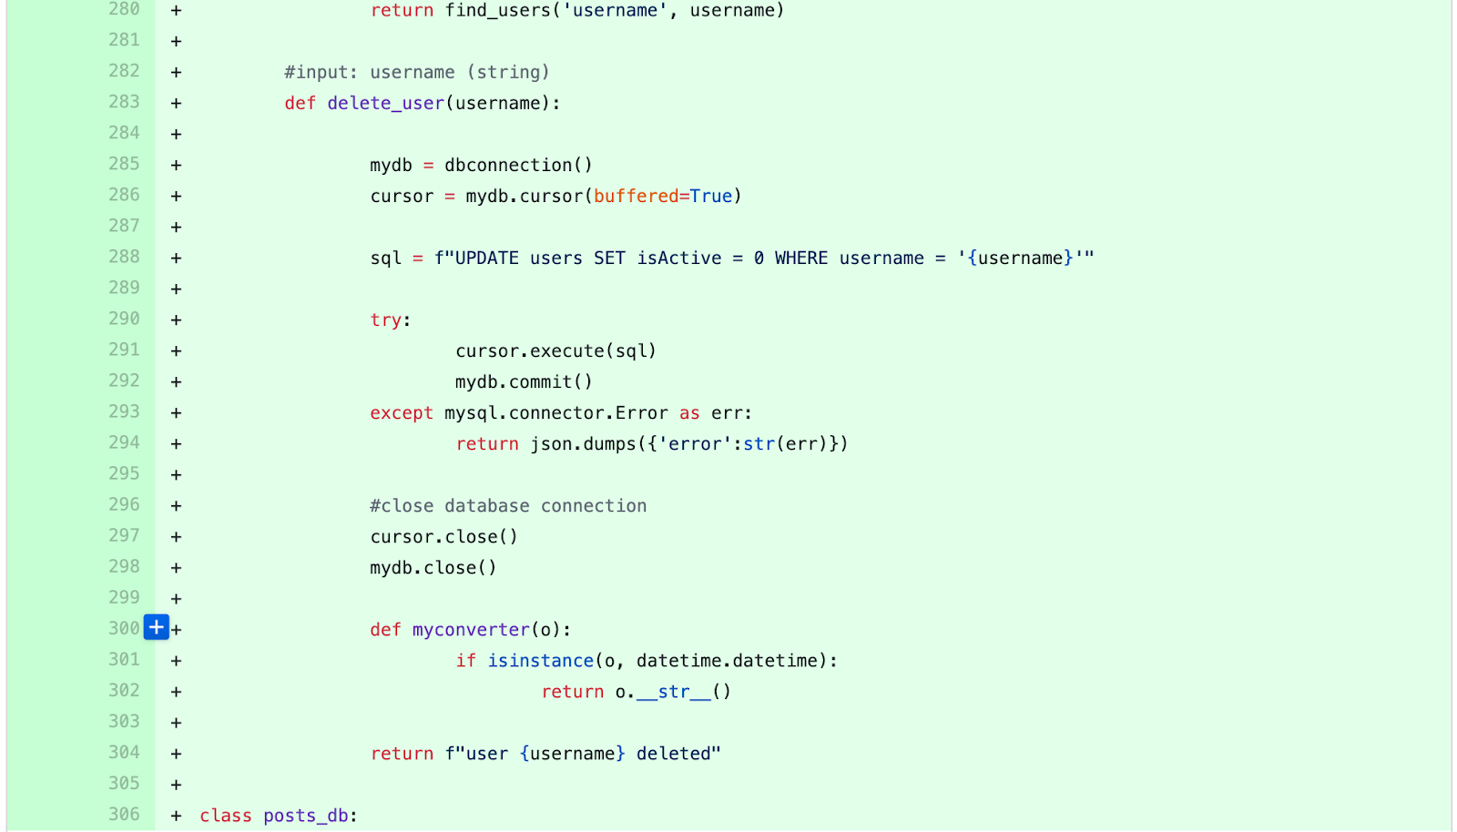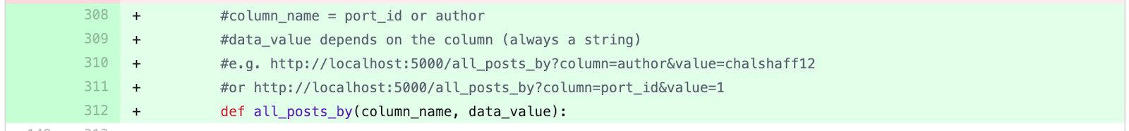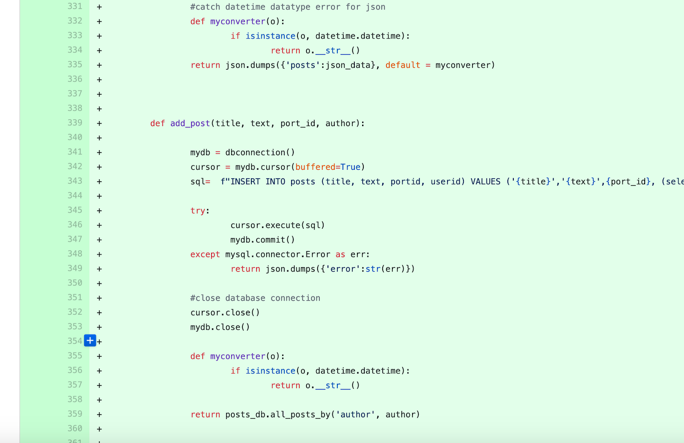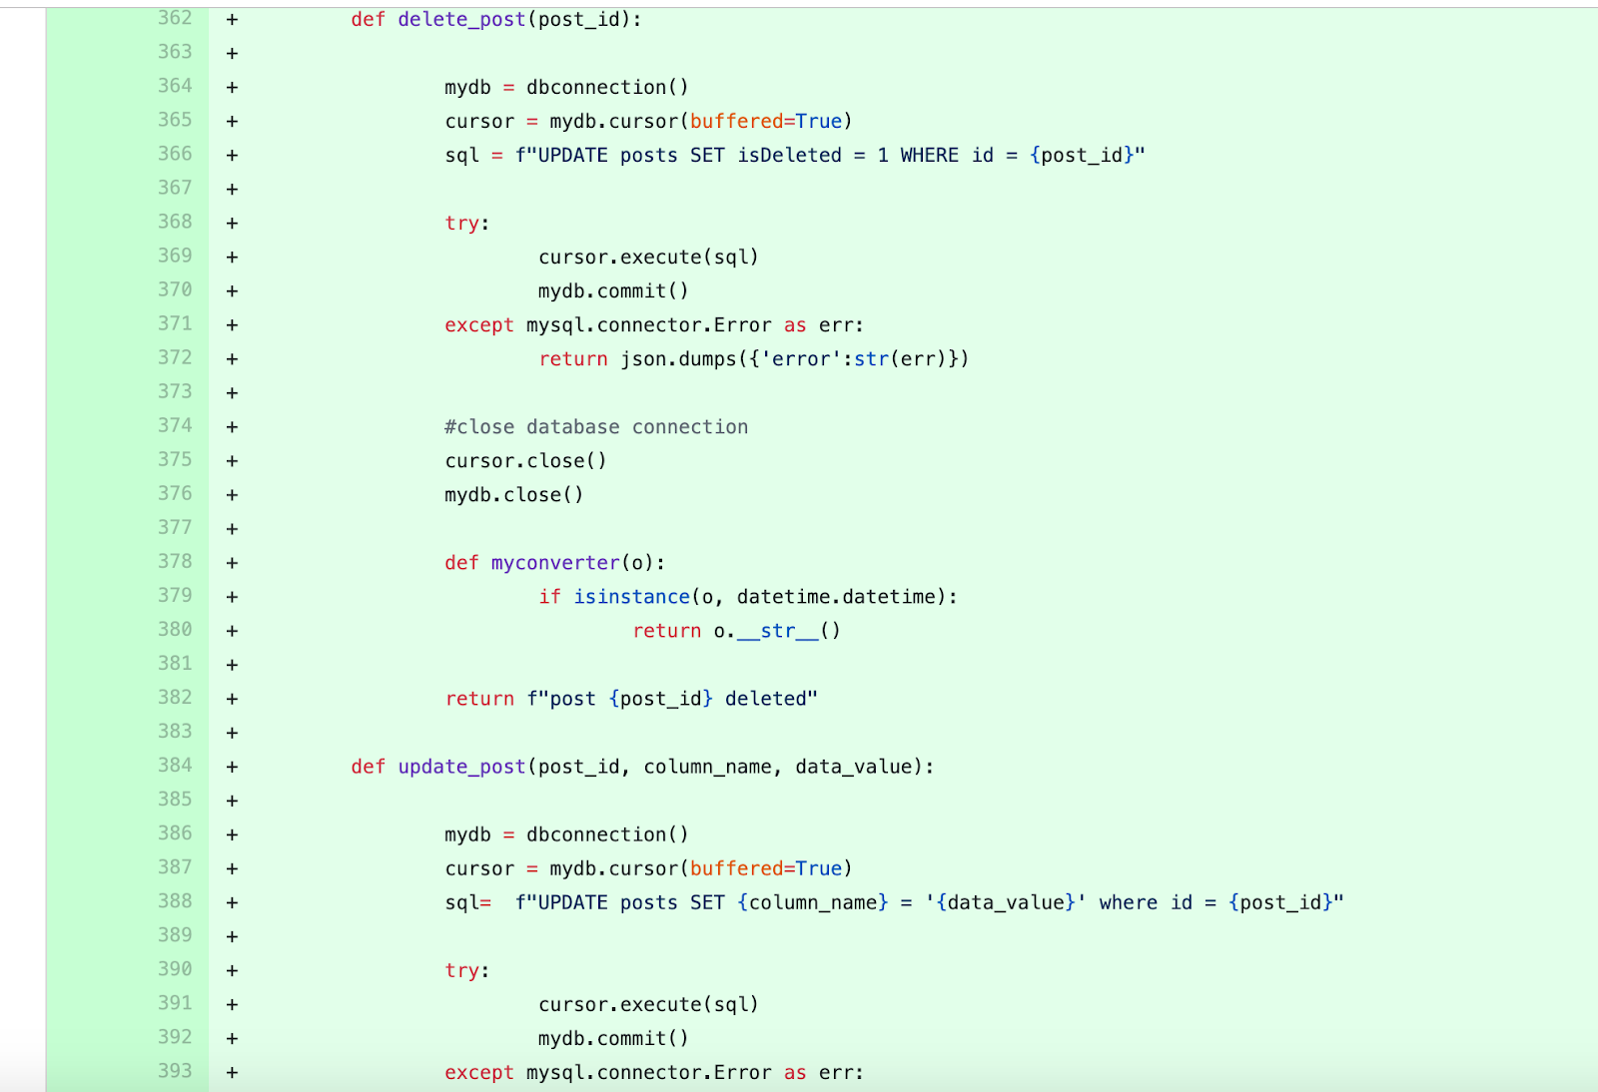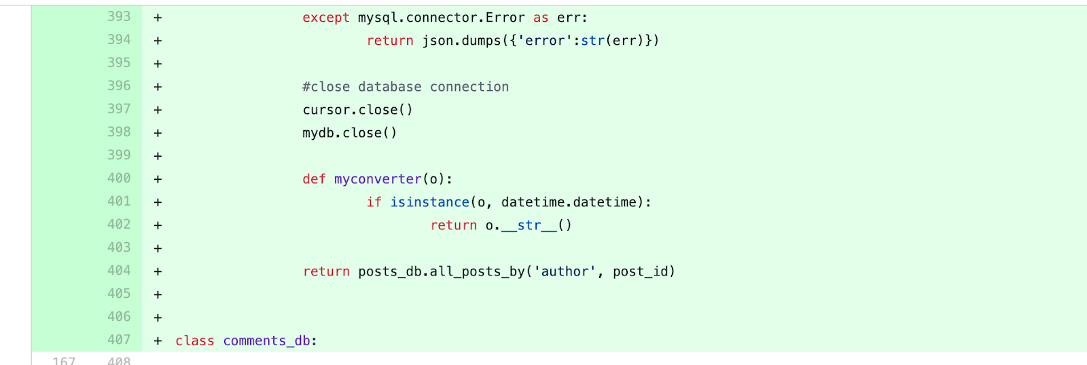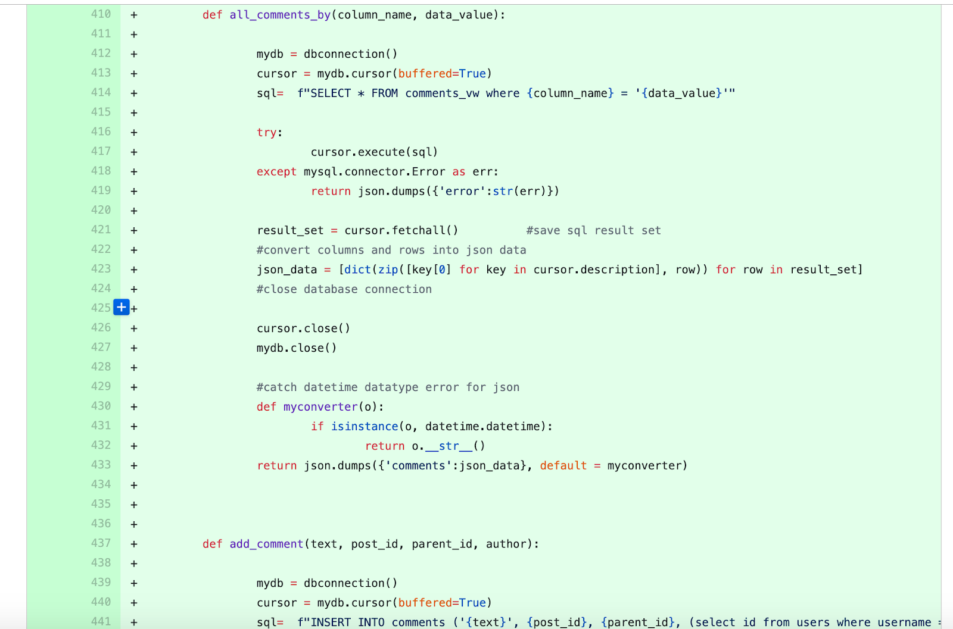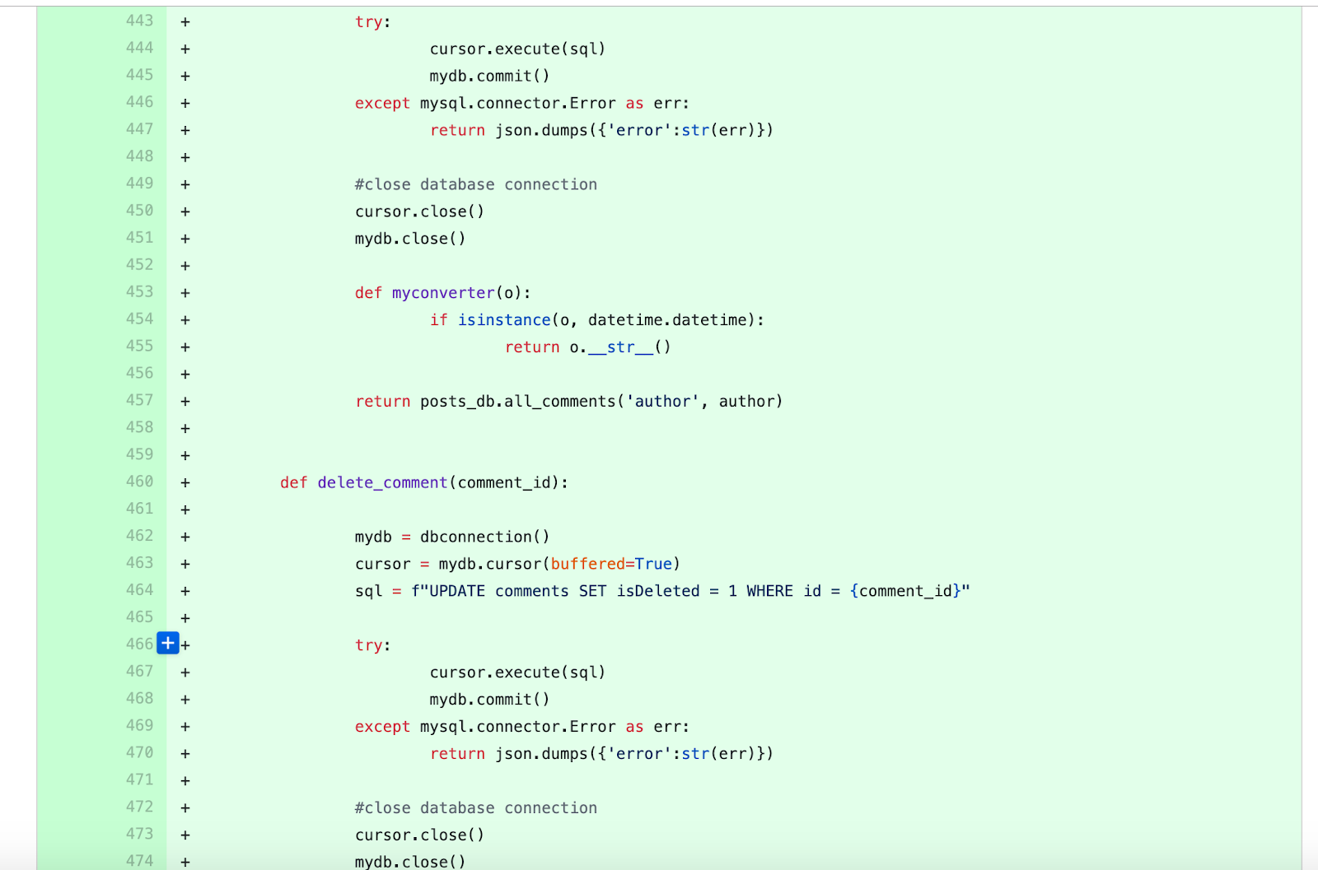

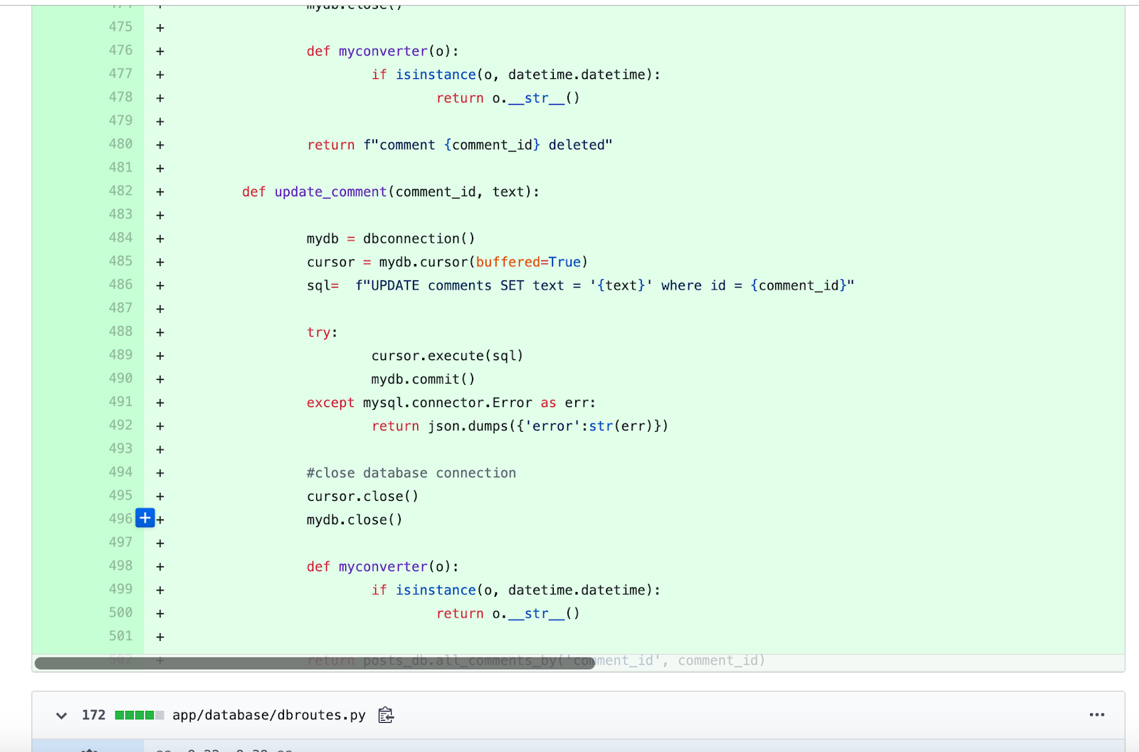

* Added Routes for the new function

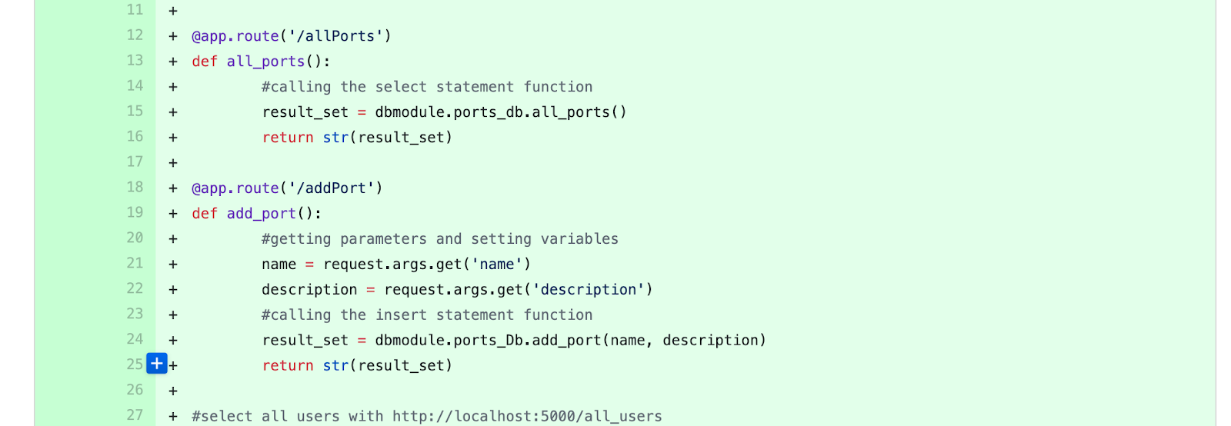https://lh4.googleusercontent.com/aYvBz1OcsFMzoY_yQOm7BnswRy7PhCp7viO5Eki9vpxzZoDQWEMtL2OWaNT6LNxi8rzwmPcNgNLfAKZ5gt3tFy7u9IzWCasll4rDV1Jw4Y9fcL3kD80Szat2172y5wTA7WOOV5c0qufRKhRc9g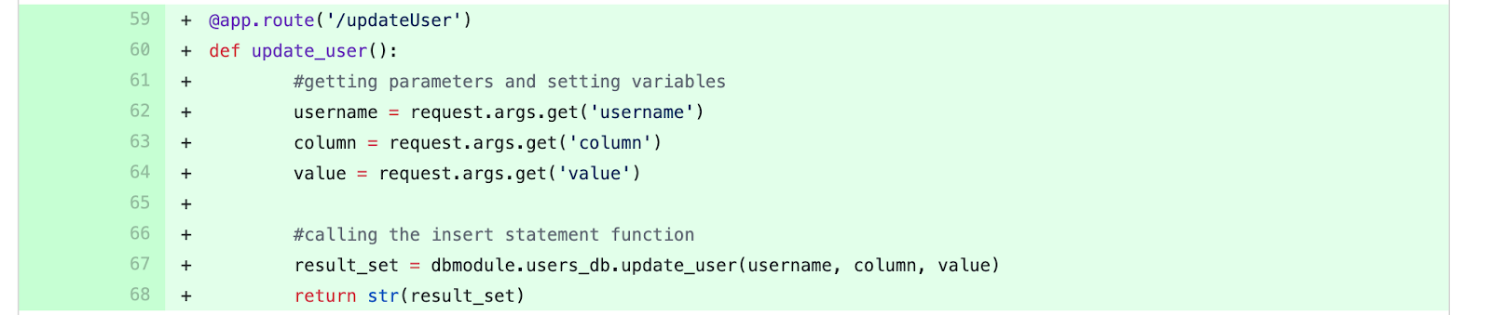https://lh6.googleusercontent.com/B2Fa_bLA2O3k-tHeXyI0C2zp1h2AmCI3ApPVKmysBwH3QfTLME43lYJgjzxjVWZzFM8koI2lZ_1QJzVYrF4aopU2UEiYt_jV_o0MvoaSO6OEojoahKKarNf5dHcuOiUjmYXS7Urikg0mkvEd-g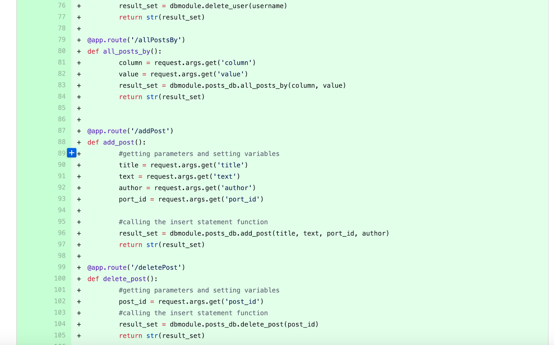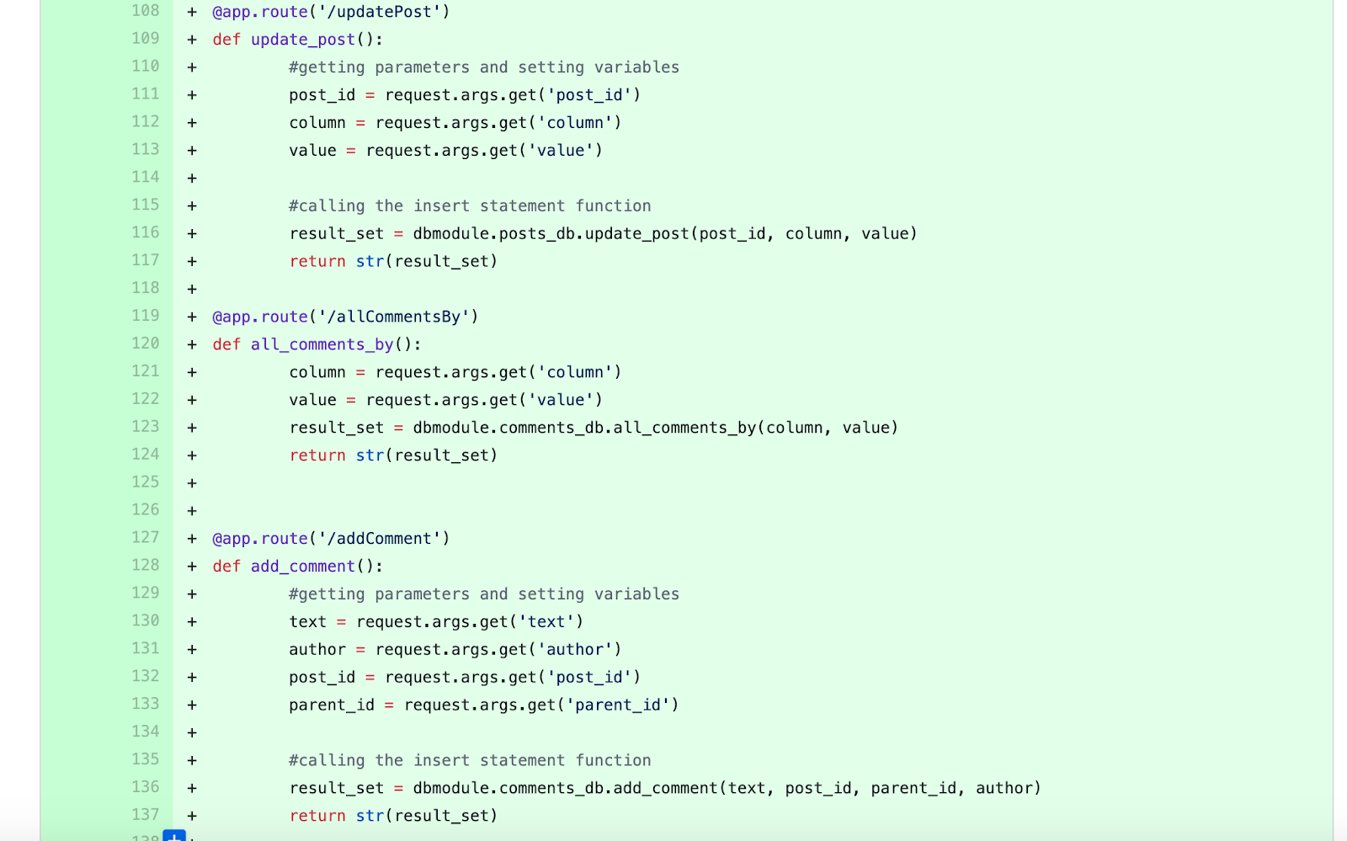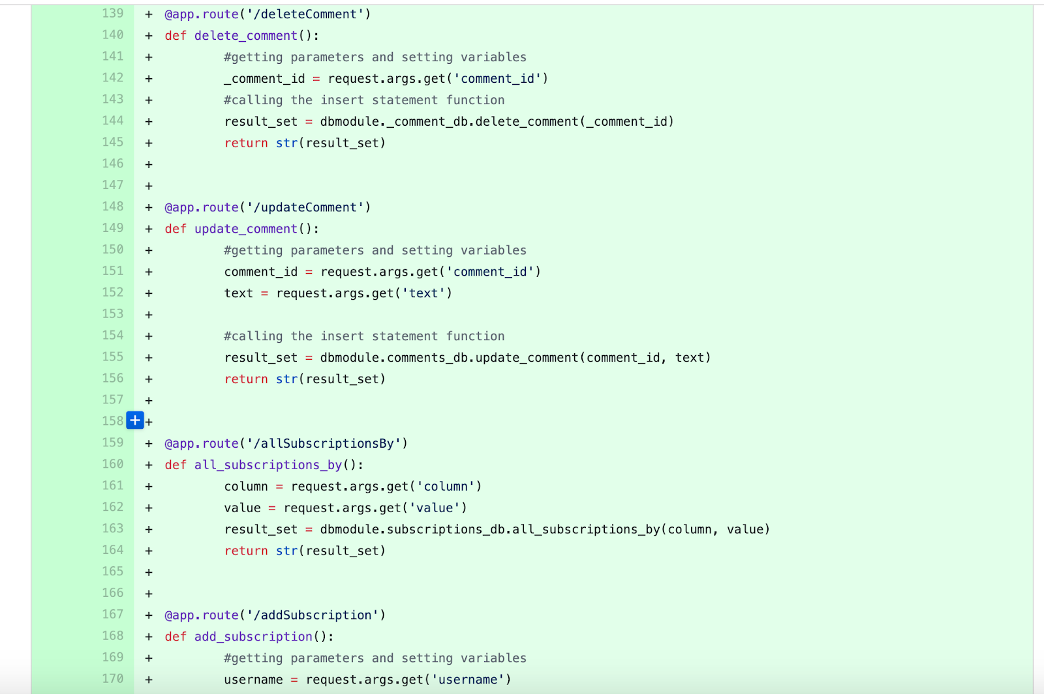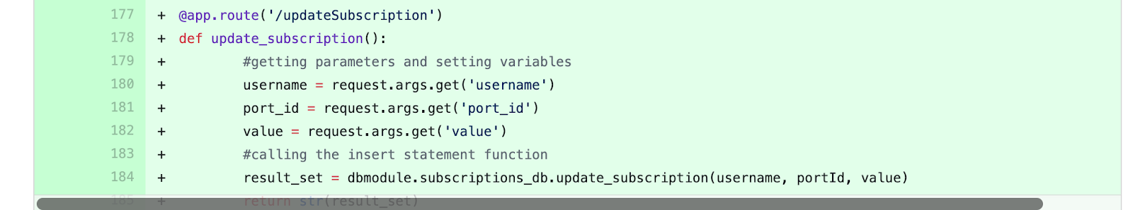

* Added views to the database

https://lh6.googleusercontent.com/hCjeHQ4ZNdOvVW204BSU57YA1rgK8McBDgGv7V9XAkeJc2D8me7G9I7Pcs7Y5J0ohSFZk8eKTNaeroSGLeCnNcQrR2n1M1CdOdbphcz3EFFTElLn_7RExHv5akB24KyPFRLOG4a6

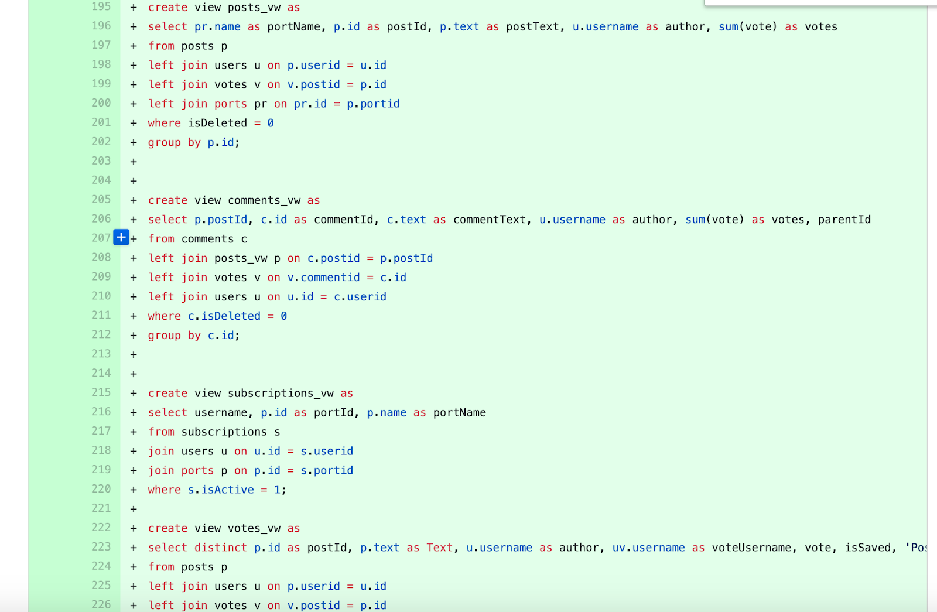

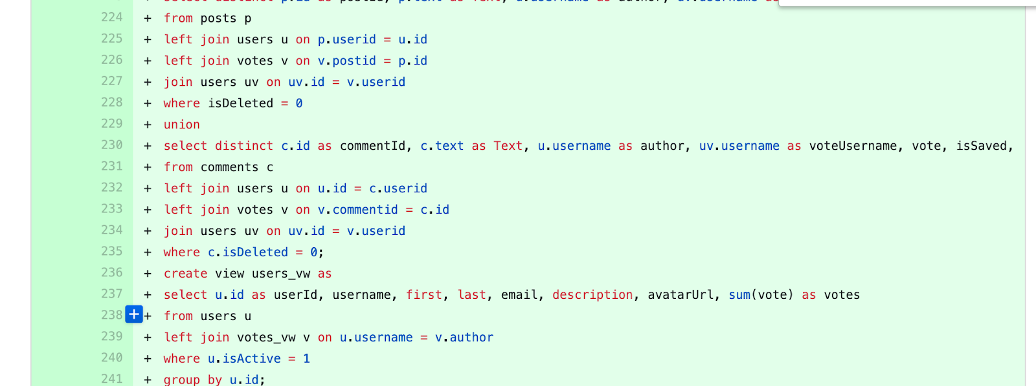

* **Added Function samples to front end pdf to back end team**

